

Department of Computer Science and Engineering

Course Title :Statistics for Data Science.

Course Code : CSE 303.

Section : 03.

Semester : Fall 2025.

Submitted to :

Sadika Islam Sneha

Lecturer, Department of Computer Science and Engineering

Submitted by
Sudipta Roy | 2021-2-60-009
Abu Zafar Mohammad Saleh Billah Mishkat | 2022-2-60-027
MD.Sifat Bin Islam | 2023-2-60-117
Zuwayeeria Binte Sharif | 2023-2-60-279
Fariha Afrin Moni | 2023-3-60-571

Project Report: Modeling the Relationship Between Workload and Mental Health in University Students

1. Introduction & Background
University students face numerous challenges that can impact their mental health and academic performance. Academic stress stemming from heavy workloads, tight deadlines, and the pressure to balance studies with extracurricular activities and part-time employment has become increasingly prevalent in higher education settings. This stress can manifest in various ways, including anxiety, sleep disturbances, and decreased cognitive functioning.
This project aims to investigate the quantitative relationship between various workload metrics and mental health indicators among university students. By applying statistical methods including hypothesis testing and regression analysis, we seek to identify significant predictors of student mental health outcomes and provide evidence-based recommendations.

2. Survey Design & Data Description

2.1 Survey Instrument
The survey was designed to capture demographic information, academic workload factors, and mental health indicators. The instrument included questions about:
- Demographics: year of study, gender, age, and CGPA
- Workload factors: weekly study hours, number of courses, extracurricular activities, and part-time job hours
- Mental health indicators: self-reported stress levels (1-5 scale), anxiety levels (1-5 scale), sleep hours, and sleep quality (1-10 scale)

2.2 Data Collection
A total of 82 responses were collected from university students. This satisfies the minimum requirement of 80 responses specified in the project guidelines.

2.3 Data Cleaning and Preprocessing
The raw dataset underwent extensive cleaning and transformation:
- Column names were standardized and mapped to consistent naming conventions
- Missing values were handled appropriately
- Categorical variables were encoded numerically
- New derived variables were created:
  - sleep_deficit (binary variable indicating sleep <6 hours)
  - sleep_squared (quadratic term for sleep hours to capture non-linear relationships)
The final cleaned dataset contained 82 observations with 16 variables after preprocessing.

2.4 Sample Characteristics
The sample consisted of students with the following characteristics:
- Mean age: 22.56 years (SD = 1.23, range: 20-25)
- Mean CGPA: 3.43 (SD = 0.47, range: 2.12-4.0)
- Mean number of courses: 4.14 (SD = 2.09, range: 1-13)
- Mean weekly job hours: 8.10 hours (SD = 13.21, range: 0-45)
- Mean nightly sleep hours: 6.57 hours (SD = 1.56, range: 4-12)
- Mean sleep quality: 6.22/10 (SD = 2.23, range: 1-10)
- Mean stress level: 3.45/5 (SD = 1.23, range: 1-5)
- Mean anxiety level: 3.24/5 (SD = 1.44, range: 1-5)
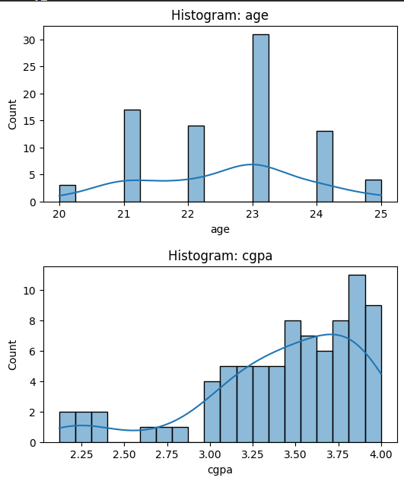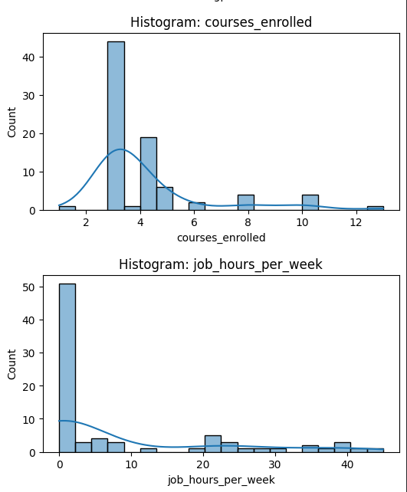

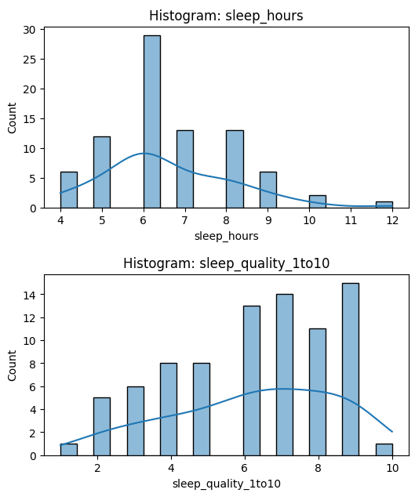

3. Exploratory Data Analysis (EDA)

3.1 Distribution Analysis
Key observations from the distribution analysis:
- Sleep hours showed a right-skewed distribution with most students reporting 6-8 hours per night
- Stress levels were bimodal, with peaks at moderate (3) and high (4-5) levels
- A significant portion of students (approximately 30%) reported sleep deficits (<6 hours per night)
- Course enrollment varied widely, with most students taking 3-4 courses per semester

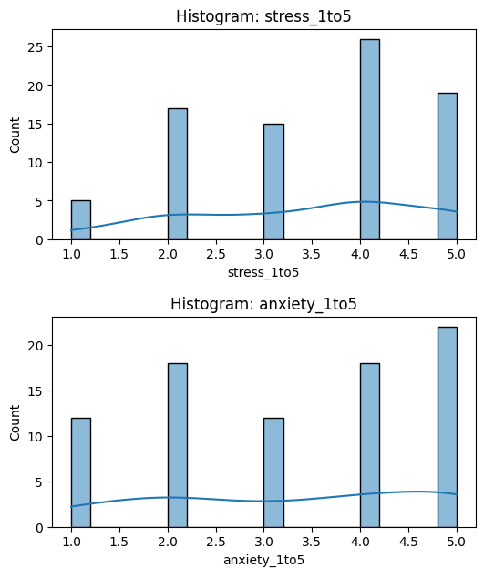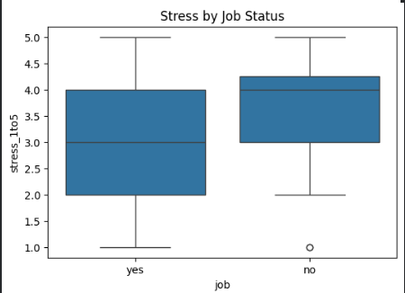

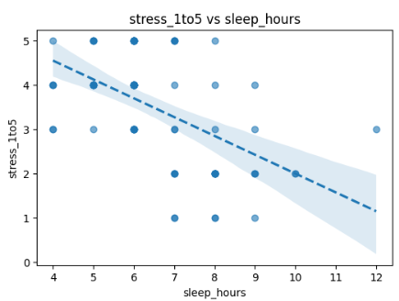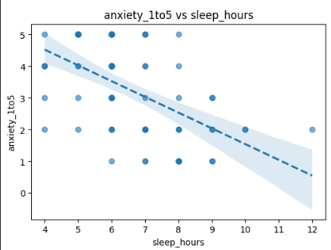

3.2 Correlation Analysis
Correlation analysis revealed several important relationships:
- Strong negative correlation between sleep hours and stress level (r = -0.54)
- Moderate negative correlation between sleep quality and stress (r = -0.50)
- Moderate positive correlation between number of courses and stress level (r = 0.32)
- Weak negative correlation between job hours and stress (r = -0.22)
Sleep-related variables showed the strongest correlations with stress levels, suggesting that sleep quality and duration may be more important predictors of student stress than traditional workload measures like study hours.

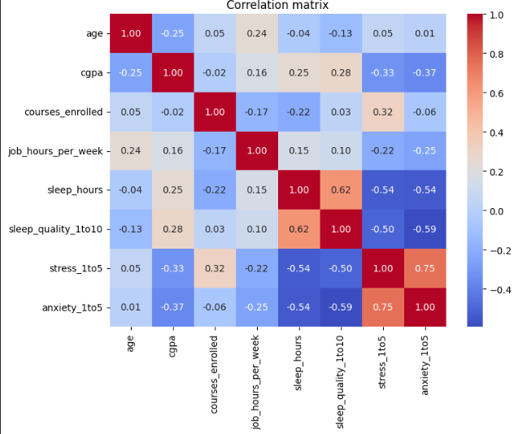

4. Hypothesis Testing

4.1 Stress by Job Status
Hypotheses:
- H₀: μ(stress | job=Yes) = μ(stress | job=No)
- H₁: μ(stress | job=Yes) ≠ μ(stress | job=No)
Test: Independent t-test (Welch's) with Levene's test for equal variances
Significance level: α = 0.05
Results:
- Levene's test p-value = 0.133 (equal variances assumption met)
- t(80) = -1.729, p = 0.0896
- Cohen's d = -0.414 (small to medium effect size)
Conclusion: We fail to reject the null hypothesis at α = 0.05. There is no statistically significant difference in stress levels between students with part-time jobs and those without jobs. The non-parametric Mann-Whitney U test confirmed this finding (p = 0.095).

4.2 Anxiety Across Year of Study
Hypotheses:
- H₀: μ₁ = μ₂ = μ₃ = μ₄ (all year means equal)
- H₁: At least one mean differs
Test: One-way ANOVA
Significance level: α = 0.05
Results:
- Levene's test p-value = 0.914 (homogeneity of variances assumption met)
- F(3, 78) = 0.546, p = 0.6522
- η² = 0.021 (very small effect size)
Conclusion: We fail to reject the null hypothesis. There is no statistically significant difference in anxiety levels across different years of study. The effect size is very small, suggesting minimal practical significance even if a larger sample might detect a statistically significant difference.

4.3 Proportion Test: High Stress by Job Status
Hypotheses:
- H₀: p(high stress | job=Yes) = p(high stress | job=No)
- H₁: p(high stress | job=Yes) ≠ p(high stress | job=No)
Test: Two-proportion z-test
Significance level: α = 0.05
Results:
- z = -1.596, p = 0.1106
Conclusion: We fail to reject the null hypothesis. The proportion of students reporting high stress is not significantly different between students with part-time jobs and those without jobs.

5. Regression Analysis

5.1 Feature Selection
Correlation analysis with the target variable (stress) revealed the following absolute correlations:
- Sleep hours: r = 0.537
- Sleep squared: r = 0.523
- Sleep quality: r = 0.504
- Low sleep quality indicator: r = 0.408
- Courses enrolled: r = 0.319
- Sleep deficit indicator: r = 0.287
- Job hours: r = 0.220
Based on these correlations and VIF analysis to avoid multicollinearity, the features selected for advanced modeling were sleep hours and sleep squared.

5.2 Advanced Regression Models
Three regression algorithms were compared:
- Ordinary Least Squares (OLS)
- Ridge Regression
- Lasso Regression
Model Performance (Test Set):
Model | R² | RMSE | MAE | Best Alpha
OLS | -0.052 | 1.041 | 0.874 | -
Ridge | 0.019 | 1.006 | 0.845 | 10
Lasso | 0.015 | 1.008 | 0.845 | 0.1

The advanced models showed poor predictive performance, with negative or near-zero R² values on the test set. Cross-validation showed moderate but highly variable performance (mean R² = 0.133, SD = 0.236), indicating model instability and potential overfitting.

5.3 Multiple Regression with Multiple Predictors
A multiple regression model was fitted with four predictors: courses enrolled, job hours per week, sleep hours, and sleep quality.
Model Summary:
Stress = 4.859 + 0.206 × courses_enrolled - 0.010 × job_hours - 0.111 × sleep_hours - 0.265 × sleep_quality
- R² = 0.510, Adjusted R² = 0.472
- F(4, 52) = 13.51, p < 0.001
Significant Predictors (p < 0.05):
- Courses enrolled: β = 0.206, SE = 0.058, p = 0.001
- Sleep quality: β = -0.265, SE = 0.071, p < 0.001
Non-significant Predictors:
- Job hours per week: β = -0.010, SE = 0.010, p = 0.321
- Sleep hours: β = -0.111, SE = 0.105, p = 0.297
Robust standard errors (HC3) confirmed the significance of courses enrolled and sleep quality, while the other predictors remained non-significant.
Model Diagnostics:
- Breusch-Pagan test for heteroscedasticity: p = 0.935 (no evidence of heteroscedasticity)
- VIF values: All predictors showed acceptable multicollinearity (VIF < 2) except for the intercept term
- Out-of-sample performance was poor: RMSE = 1.131, R² = -0.086
- Cross-validation performance: mean R² = 0.263 (SD = 0.332)
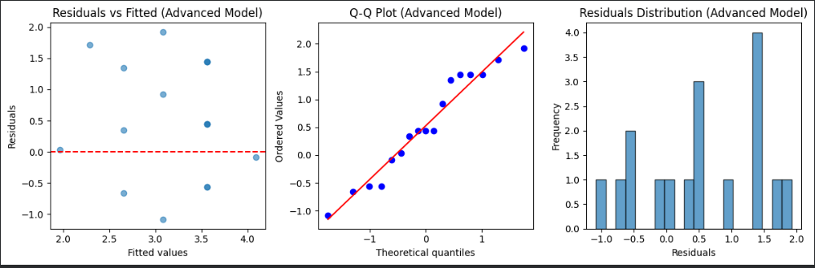

6. Interpretation of Results & Discussion

6.1 Key Findings
- Sleep quality is a critical factor: Sleep quality emerged as the strongest predictor of student stress levels, with higher quality sleep associated with significantly lower stress. This finding aligns with previous research on the importance of sleep for mental health and cognitive functioning.
- Course load impacts stress: The number of courses enrolled was positively associated with stress levels, suggesting that academic workload directly contributes to student stress. Each additional course was associated with a 0.206 increase in stress level on the 5-point scale.
- Limited evidence for job impacts: Contrary to our initial hypotheses, part-time job status and hours were not significantly associated with stress or anxiety levels. This may suggest that students who work part-time develop better time management skills or that the income from jobs reduces financial stress.
- No year-level differences: There were no significant differences in anxiety levels across different years of study, challenging the common assumption that senior students experience less stress due to better coping mechanisms.
- Model limitations: The regression models showed good in-sample fit but poor out-of-sample predictive performance, suggesting that stress is influenced by many factors beyond those captured in our survey.

6.2 Practical Implications
Based on our findings, we recommend:
- Sleep quality interventions: Universities should prioritize sleep education and create environments conducive to quality sleep. This could include quiet hours in residence halls, sleep hygiene workshops, and counseling services that address sleep issues.
- Course load management: Academic advisors should help students balance their course loads across semesters, particularly avoiding clusters of demanding courses. Departments could coordinate to prevent assignment deadlines from coinciding.
- Holistic stress assessment: Since our models explained only about 50% of the variance in stress levels, universities should adopt comprehensive approaches to student wellness that consider factors beyond academic workload.
- Individualized support: Given the high variability in stress responses to similar conditions, support services should be personalized rather than one-size-fits-all.

7. Limitations and Suggestions for Future Work

7.1 Limitations
- Sample size constraints: With only 82 respondents, the study had limited statistical power to detect small to medium effects, particularly for subgroup analyses.
- Cross-sectional design: The snapshot nature of the data prevents causal inferences about the relationship between workload factors and stress.
- Self-reported measures: All variables were self-reported, potentially introducing common method bias and social desirability effects.
- Model overfitting: The significant difference between in-sample R² (0.51) and out-of-sample R² (-0.086) suggests overfitting, limiting the predictive utility of our models.
- Limited demographic diversity: The sample may not represent the full diversity of the student population across different fields of study and backgrounds.

7.2 Future Research Directions
- Longitudinal studies: Tracking students across multiple semesters would help establish temporal relationships between workload changes and stress fluctuations.
- Objective measures: Incorporating objective measures of sleep (wearable devices) and workload (digital study tracking) would enhance validity.
- Expanded variable set: Future research should include additional factors known to affect student stress, such as financial concerns, social support, and coping strategies.
- Intervention studies: Testing specific interventions focused on improving sleep quality and managing course loads would provide evidence for effective practices.
- Machine learning approaches: More sophisticated modeling techniques might better capture the complex, non-linear relationships between multiple stressors and mental health outcomes.

8. Conclusion
This study provides evidence that sleep quality and course load are significant predictors of stress among university students, while part-time employment appears to have minimal impact on stress levels. The findings challenge some common assumptions about student stress and highlight the importance of sleep quality as a protective factor.
The regression models explained approximately 51% of the variance in stress levels, indicating that these factors are important but not comprehensive predictors of student mental health. The poor out-of-sample performance suggests that stress is influenced by many contextual and individual factors beyond those measured in this study.
University administrators and student support services should consider implementing targeted interventions focused on improving sleep quality and helping students manage their course loads effectively. Future research should adopt longitudinal designs and incorporate objective measures to strengthen causal inferences and improve predictive models of student mental health.

Appendix A: Survey Instrument
Survey Link :
https://docs.google.com/forms/d/e/1FAIpQLScwb_EfFiUIMJph50l_cch8gR2vqEmW8xeMR0SXsQy5Es9D0w/viewform

Appendix B: Code Repository

Project colab url : https://colab.research.google.com/drive/1t8xjel2mGH9HfvZ_PRmbQejn1bIV8iZT#scrollTo=m-2uBtKRRWFX

Project dashboard url : https://cse303project-l8v5rahzexs65ygeizpz2z.streamlit.app/#interactive-visualizations

All files repository : https://github.com/sudiptoroy7666-lgtm/CSE_303_project/tree/main

